PRACTICAL-3
Name: Ashwini Ravindra Kadam
PRN: 202501050017
Division: Chemical(CH-1)

3.1.1. Numpy Array Operations
Write a Python program to create a NumPy array based on user input and display the following:
- The created NumPy array.
- The number of dimensions of the array using ndim
- The shape of the array using shape
- The total number of elements in the array using size Assume all input elements are valid integers.
Input Format:
- The first line contains two space-separated integers, and , representing the number of rows and the number of columns.
- The next lines contain space-separated integers representing the elements of the array, entered row by row.
Output Format:
- The created NumPy array (printed as a 2D array).
- An integer representing the number of dimensions of the array.
- A tuple representing the shape of the array.
- An integer representing the total number of elements in the array.
CODE:
import numpy as np rows, cols = map(int, input().split()) elements = [] for _ in range(rows) :
elements.extend(map(int, input().split())) array = np.array(elements).reshape(rows, cols) print(array) print(array.ndim) print(array.shape) print(array.size)
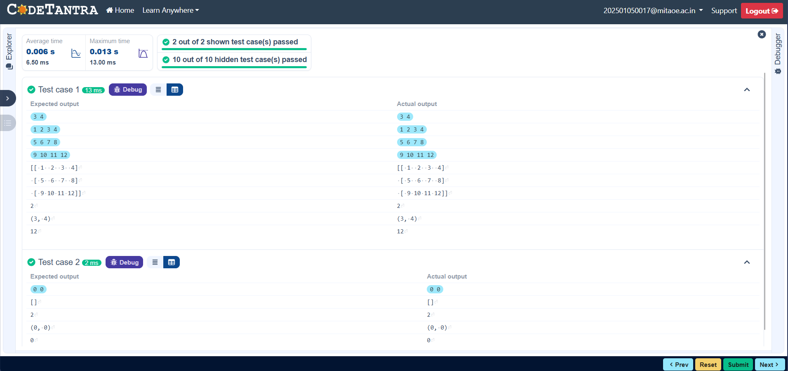

3.2.1. Numpy: Matrix Operations
The given code takes two matrices, , and , as input from the user and converts them into NumPy arrays.
Task:
You are required to compute and display the results of the following matrix operations:
- Addition ()
- Subtraction ()
- Element-wise Multiplication ()
- Matrix Multiplication ()
- Transpose of Matrix A Input Format:
- The user will input 3 rows for , each containing 3 integers separated by spaces.
- Similarly, the user will input 3 rows for , each containing 3 integers separated by spaces.
Output Format:
The program should display the results of the operations in the following order:
- The result of Addition.
- The result of Subtraction.
- The result of Element-wise Multiplication.
- The result of Matrix Multiplication.
- The Transpose of Matrix A.
CODE
import numpy as np # Input matrices print("Enter Matrix A:") matrix_a = np.array([list(map(int, input().split())) for i in range(3)]) print("Enter Matrix B:") matrix_b = np.array([list(map(int, input().split())) for i in range(3)])
# Addition addition_result = matrix_a + matrix_b print("Addition (A + B):") print(addition_result) # Subtraction subtraction_result = matrix_a - matrix_b print("Subtraction (A - B):") print(subtraction_result) # Multiplication (element-wise) elementwise_multiplication_result = matrix_a * matrix_b
print("Element-wise Multiplication (A * B):") print(elementwise_multiplication_result) # Matrix multiplication (dot product) matrix_multiplication_result=np.dot(matrix_a, matrix_b) print("A dot B:")
print(matrix_multiplication_result)
# Transpose transpose_a = matrix_a.T print("Transpose of A:") print(transpose_a) 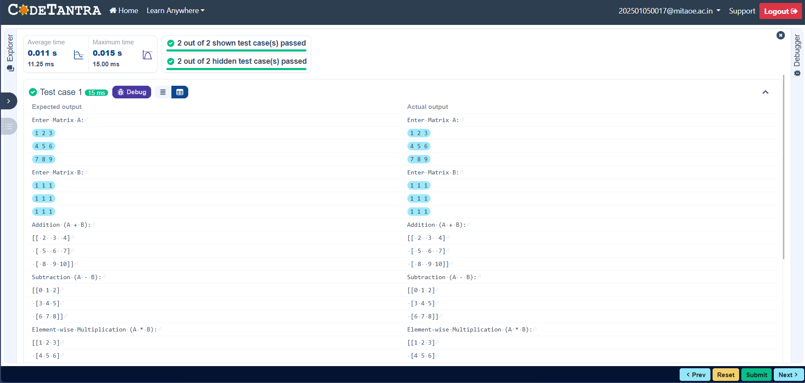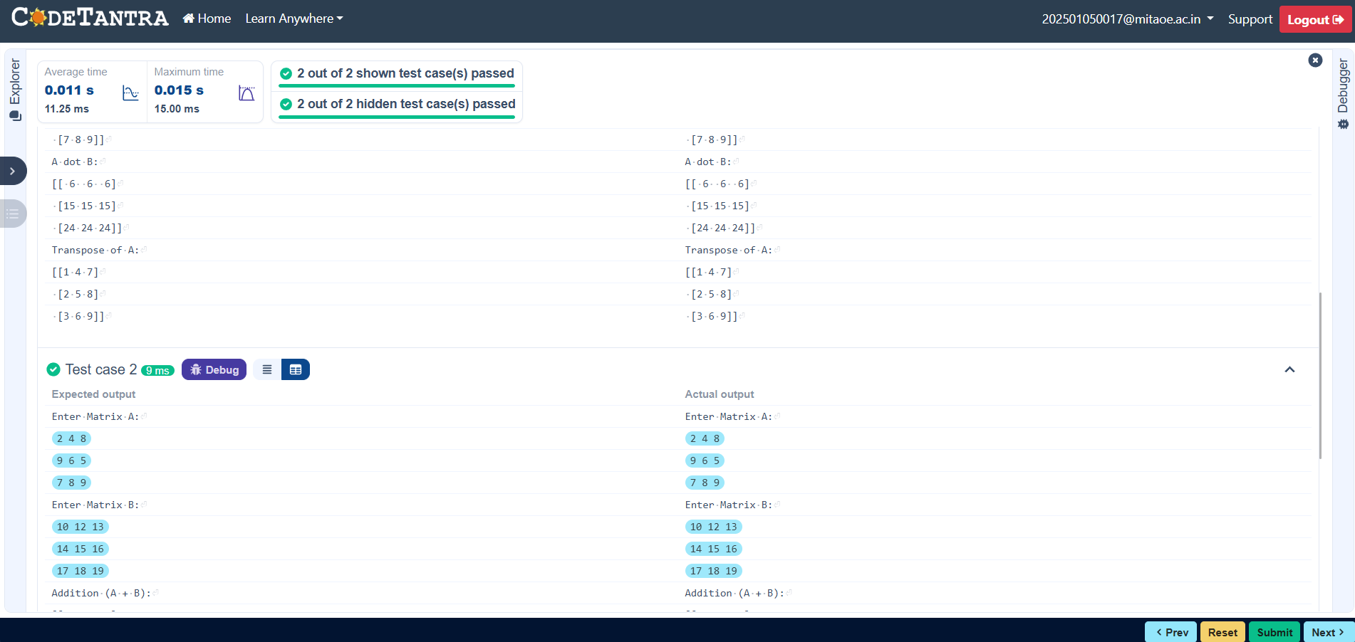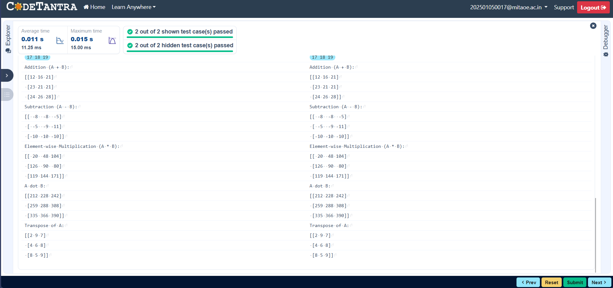

3.2.2. Numpy: Horizontal and Vertical Stacking of Arrays
You are given two arrays arr1 and arr2. You need to perform horizontal and vertical stacking operations on them using NumPy.
- Horizontal Stacking: Stack the two matrices horizontally (side by side).
- Vertical Stacking: Stack the two matrices vertically (one below the other).
Input Format:
- The program should first prompt the user to input two 3x3 arrays.
- Each array consists of 3 rows, and each row contains 3 space-separated integers.
- The user will input the two arrays row by row.
Output Format:
- The program should display the result of the Horizontal Stack (side-by-side stacking) of the two arrays.
- The program should then display the result of the Vertical Stack (one below the other) of the two arrays.
CODE:
import numpy as np # Input matrices print("Enter Array1:") arr1 = np.array([list(map(int, input().split())) for i in range(3)]) print("Enter Array2:") arr2 = np.array([list(map(int, input().split())) for i in range(3)])
# Perform horizontal stacking (hstack) a=np.hstack((arr1,arr2)) print("Horizontal Stack:") print(a)
# Perform vertical stacking (vstack) b=np.vstack((arr1,arr2)) print("Vertical Stack:")
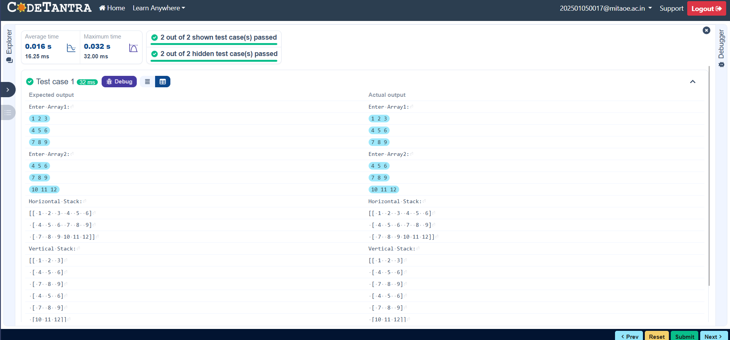
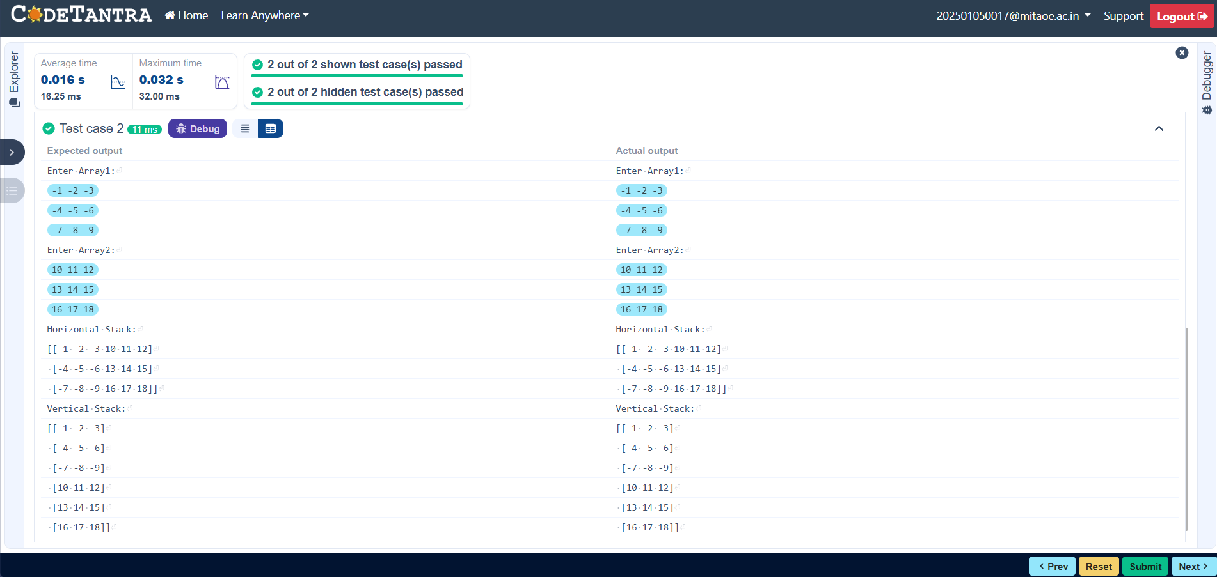

3.2.3. Numpy: Custom Sequence Generation
Write a Python program that takes the following inputs from the user:
- Start value: The starting point of the sequence.
- Stop value: The sequence should end before this value.
- Step value: The increment between each number in the sequence.
The program should then generate a sequence using numpy based on these inputs and print the generated sequence. Input Format:
- The user will input three integer values: start, stop, and step, each on a new line.
Output Format:
- The program should print the generated sequence based on the input values.
CODE:
import numpy as np
# Take user input for the start, stop, and step of the sequence start = int(input()) stop = int(input()) step = int(input())
# Generate the sequence using np.arange() a= np.arange(start,stop, step) print(a)
# Print the generated sequence
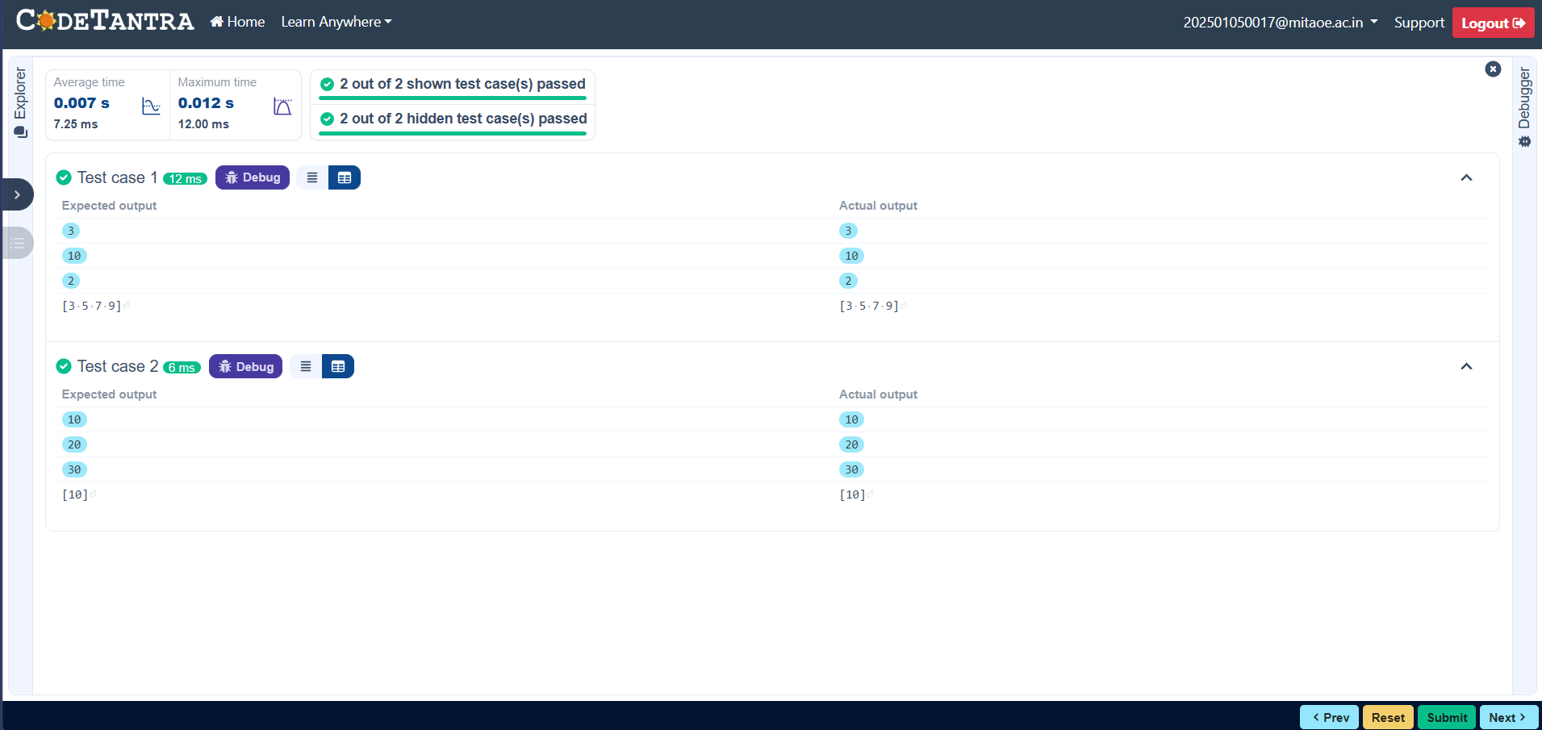

3.2.4. Numpy: Arithmetic and Statistical Operations, Mathematical Operations, Bitwise Operators
You are given two arrays A and B. Your task is to complete the function array_operations, which will convert these lists into NumPy arrays and perform the following operations:
- Arithmetic Operations:
  - Compute the element-wise sum, difference, and product of the two arrays.
- Statistical Operations:
  - Calculate the mean, median, and standard deviation of array A.
- Bitwise Operations:
  - Perform bitwise AND, bitwise OR, and bitwise XOR on the arrays (ex: A_{i} OR B_{i}).
Input Format:
  - The first line contains space-separated integers representing the elements of array A.
  - The second line contains space-separated integers representing the elements of array B.
Output Format:
  - For each operation (arithmetic, statistical, and bitwise), print the results in the specified format as shown in sample test cases.
CODE:
import numpy as np def array_operations(A, B):
# Convert A and B to NumPy arrays
    - = np.array(A)
    - = np.array(B) # Arithmetic Operations sum_result = A + B diff_result = A - B prod_result = A * B
# Statistical Operations
mean_A = np.mean(A) median_A = np.median(A) std_dev_A = np.std(A)
# Bitwise Operations
and_result = A & B
or_result = A | B
xor_result
# Output results with one space between each element print("Element-wise Sum:", ' '.join(map(str, sum_result))) print("Element-wise Difference:", ' '.join(map(str, diff_result))) print("Element-wise Product:", ' '.join(map(str, prod_result))) print(f"Mean of A: {mean_A}")
print(f"Median of A: {median_A}") print(f"Standard Deviation of A: {std_dev_A}")
print("Bitwise AND:", ' '.join(map(str, and_result))) print("Bitwise OR:", ' '.join(map(str, or_result))) print("Bitwise XOR:", ' '.join(map(str, xor_result))) A = list(map(int, input().split())) # Elements of array A B = list(map(int, input().split())) # Elements of array B
array_operations(A, B)
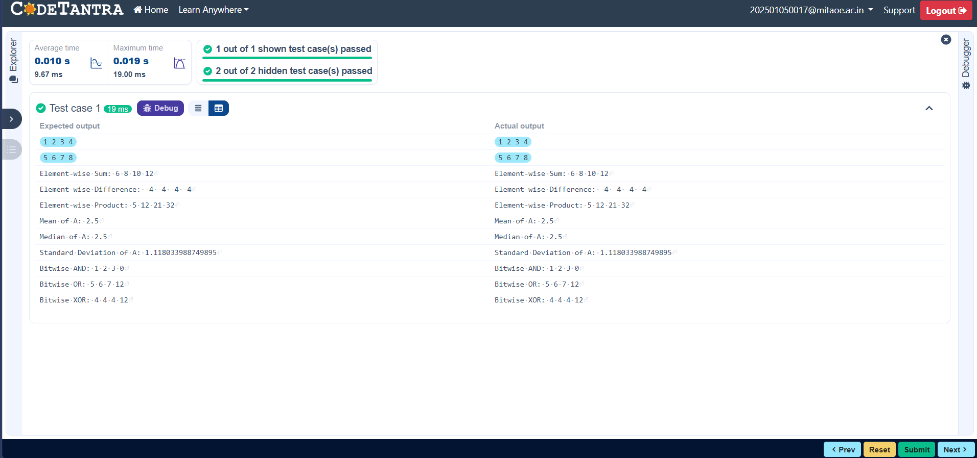

3.2.5. Numpy: Copying and Viewing Arrays
The given code takes a list of integers as input and converts it into a NumPy array. Your task is to complete the code by:
- Creating a view of the original_array and assigning it to view_array.
- Creating a copy of the original_array and assigning it to copy_array.
After completing these steps, observe how modifying the view affects the original_array, while modifying the copy does not.
Input Format:
- A single line of space-separated integers.
Output Format:
- After modifying the view:
Original array after modifying view: <original_array>
View array: <view_array>
- After modifying the copy:
Original array after modifying copy: <original_array>
Copy array: <copy_array> CODE:
import numpy as np
inputlist = list(map(int,input().split(" "))
)# Original array original_array = np.array(inputlist) # Create a view view_array =original_array.view()
# Create a copy copy_array =original_array.copy()
# Modify the view view_array[0] = 99 print("Original array after modifying view:", original_array) print("View array:", view_array)
# Modify the copy copy_array[1] = 88 print("Original array after modifying copy:", original_array) print("Copy array:", copy_array) 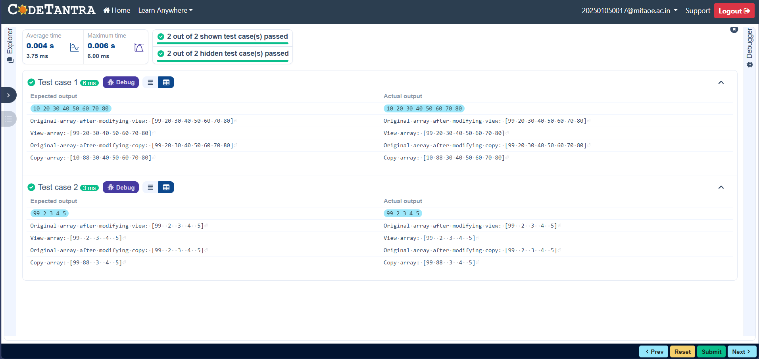

3.2.6. Numpy: Searching, Sorting, Counting, Broadcasting
The given code in the editor takes a single array, array1, as spaceseparated integers as input from the user.
Additionally, it takes the following inputs:
- search_value: The value to search for in the array.
- count_value: The value to count its occurrences in the array.
- broadcast_value: The value to add for broadcasting across the array.You need to complete the code to perform the following operations:
- Searching: Find the indices where search_value appears in array1 and print these indices.
- Counting: Count how many times count_value appears in array1 and print the count.
- Broadcasting: Add broadcast_value to each element of array1 using broadcasting, and print the resulting array.
- Sorting: Sort array1 in ascending order and print the sorted array.
Input Format:
  - A single line containing space-separated integers representing array1.
  - An integer search_value represents the value to search for in the array.
  - An integer count_value represents the value to count in the array.
  - An integer broadcast_value represents the value to add to each element of the array.
Output Format:
  - The indices where search_value occurs in array1.
  - The count of occurrences of count_value in array1.
  - The array after adding the broadcast_value to each element.
  - The sorted array.
CODE:
import numpy as np# Input array from the user array1 = np.array(list(map(int, input().split())))
# Searching search_value = int(input("Value to search: ")) count_value = int(input("Value to count: ")) broadcast_value = int(input("Value to add: ")) # Find indices where value matches in array1 a=np.where(array1==search_value)[0] print(a)
# Count occurrences in array1 b=np.count_nonzero(array1==count_value) print(b)
# Broadcasting addition c=array1 + broadcast_value print(c)
# Sort the first array d=np.sort(array1) print(d) 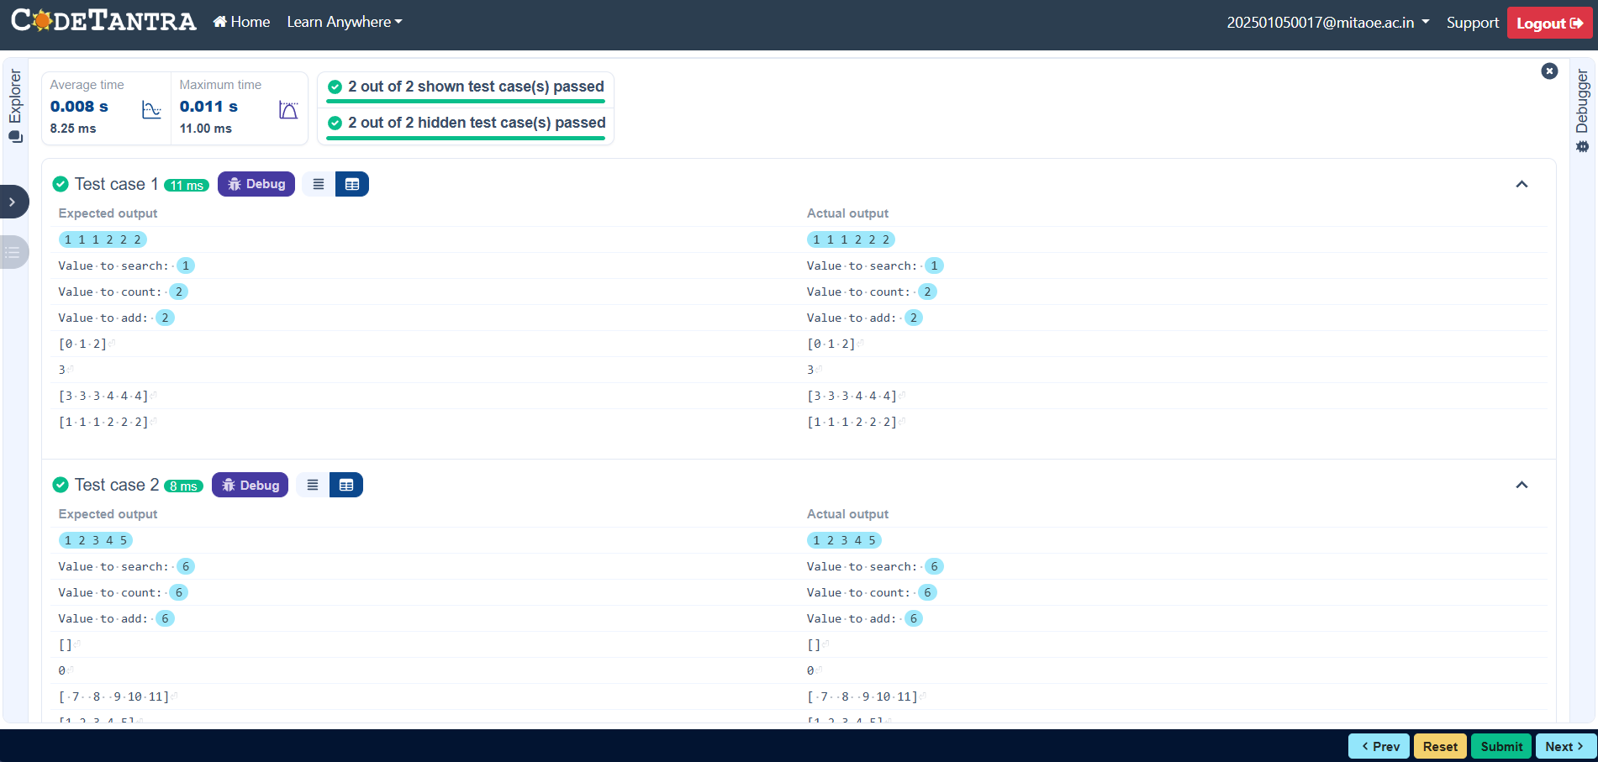

3.2.7. Student Data Analysis and Operations
Write a Python program that takes the file name of a CSV file containing student details, including roll numbers and their marks in three subjects as input, reads the data, and performs the following operations:
- Print all student details: Display the complete details of all students, including roll numbers and marks for all subjects.
- Find total students: Determine the total number of students in the dataset.
- Print all student roll numbers: Extract and print the roll numbers of all students.
- Print Subject 1 marks: Extract and print the marks of all students in Subject 1.
- Find minimum marks in Subject 2: Identify the lowest marks in Subject 2.
- Find maximum marks in Subject 3: Identify the highest marks in Subject 3.
- Print all subject marks: Display the marks of all students for each subject.
- Find total marks of students: Compute the total marks for each student across all subjects.
- Find the average marks of each student: Compute the average marks for each student.
- Find average marks of each subject: Compute the average marks for all students in each subject.
- Find average marks of Subject 1 and Subject 2: Compute the average marks for Subject 1 and Subject 2.
- Find average marks of Subject 1 and Subject 3: Compute the average marks for Subject 1 and Subject 3.
- Find the roll number of the student with maximum marks in Subject 3: Identify the student with the highest marks in Subject 3 and print their roll number.
- Find the roll number of the student with minimum marks in Subject 2: Identify the student with the lowest marks in Subject 2 and print their roll number.
- Find the roll number of students who scored 24 marks in Subject 2: Identify students who obtained exactly 24 marks in Subject 2 and print their roll numbers.
- Find the count of students who got less than 40 marks in Subject 1: Count the number of students who scored less than 40 marks in Subject 1.
- Find the count of students who got more than 90 marks in Subject 2: Count the number of students who scored more than 90 marks in Subject 2.
- Find the count of students who scored >=90 in each subject: Count the number of students who scored 90 or more marks in each subject.
- Find the count of subjects in which each student scored >=90: Determine how many subjects each student scored 90 or more marks in.
- Print Subject 1 marks in ascending order: Sort and print the marks of students in Subject 1 in ascending order.
- Print students who scored between 50 and 90 in Subject 1: Display students who scored marks between 50 and 90 in Subject 1.
- Find index positions of students who scored 79 in Subject 1: Identify the index positions of students who scored exactly 79 marks in Subject 1.
CODE:
import numpy as npa = np.loadtxt("Sample.csv", delimiter=',', skiprows=1)
# 1. Print all student details print("All student Details:\n",a)
# 2. print total students
print("Total Students:",a.shape[0]) # 3. Print all student Roll numbers print("All Student Roll Nos",a[:,0]) # 4. Print subject 1 marks print("Subject 1 Marks",a[:,1]) # 5. print minimum marks of Subject 2 print("Min marks in Subject 2",np.min(a[:,2])) # 6. print maximum marks of Subject 3 print("Max marks in Subject 3",np.max(a[:,3]))
# 7. Print All subject marks print("All subject marks:",a[:,1:4]) # 8. print Total marks of students print("Total Marks",np.sum(a[:,1:4],axis=1))
# 9. print average marks of each student
#Note:Expected output shows rounded values like 77.3 print(np.round(np.mean(a[:,1:4],axis=1),1)) # 10. print average marks of each subject print("Average Marks of each
subject",np.round(np.mean(a[:,1:4],axis=0),1))
# 11. print average marks of S1 and S2
#The test case expected[71.7 59.8], which are the individual subject averages
print("Average Marks of S1 and
S2",np.round(np.mean(a[:,1:3],axis=0),1)) # 12. print average marks of S1 and S3 print("Average Marks of S1 and S3",np.round(np.mean(a[:,[1, 3]],axis=0),1))
# 13. print Roll number who got maximum marks in Subject 3 print("Roll no who got maximum marks in Subject 3",a[np.argmax(a[:,3]),0])
# 14. print Roll number who got minimum marks in Subject 2 print("Roll no who got minimum marks in Subject 2",a[np.argmin(a[:,2]),0])
# 15. print Roll number who got 24 marks in Subject 2 print("Roll no who got 24 marks in Subject 2",a[a[:,2]==24][:,0:1]) # 16. print count of students who got marks in Subject 1 < 40 print("Count of students who got marks in Subject 1 < 40",np.sum(a[:,1]<40))
# 17. print count of students who got marks in Subject 2 > 90 print("Count of students who got marks in Subject 2 > 90:",np.sum(a[:,2]>90))
# 18. print count of students in each subject who got marks >= 90 print("Count of students in each subject who got marks >= 90:",np.sum(a[:,1:4]>=90,axis=0))# 19. print count of subjects in which each student got marks >= 90 print("Roll no:",a[:,0])
print("Count of subjects in which student got marks >= 90:",np.sum(a[:,1:4]>=90,axis=1)) # 20. Print S1 marks in ascending order print(np.sort(a[:,1]))
# 21. Print S1 marks >= 50 and <=
90print(a[(a[:,1]>=50)&(a[:,1]<=90)])
#Bonus: The test case shows the full array printed again before the index positions print(a)
# 22. Print the index position of marks 79 # Expected format:(array([6,9],dtype=int32),) print(np.where(a[:,1]==79))
